**Week-5**

**2. Microservices with API gateway**

**Hands on 1**

**Creating Microservices for account and loan**

**1. Account Microservice**

**Code:**

**AccountController.java**

package com.cognizant.account.controller;

import org.springframework.web.bind.annotation.*;

@RestController

public class AccountController {

@GetMapping("/accounts/{number}")

public Account getAccount(@PathVariable String number) {

return new Account(number, "savings", 20000);

}

}

class Account {

private String number;

private String type;

private double balance;

public Account(String number, String type, double balance) {

this.number = number;

this.type = type;

this.balance = balance;

}

public String getNumber() {

return number;

}

public String getType() {

return type;

}

public double getBalance() {

return balance;

}

}

**Application Properties**

spring.application.name=account

server.port = 8080

**Output:**

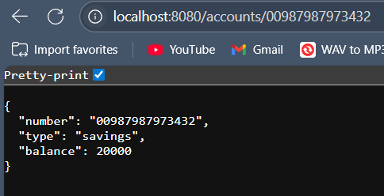

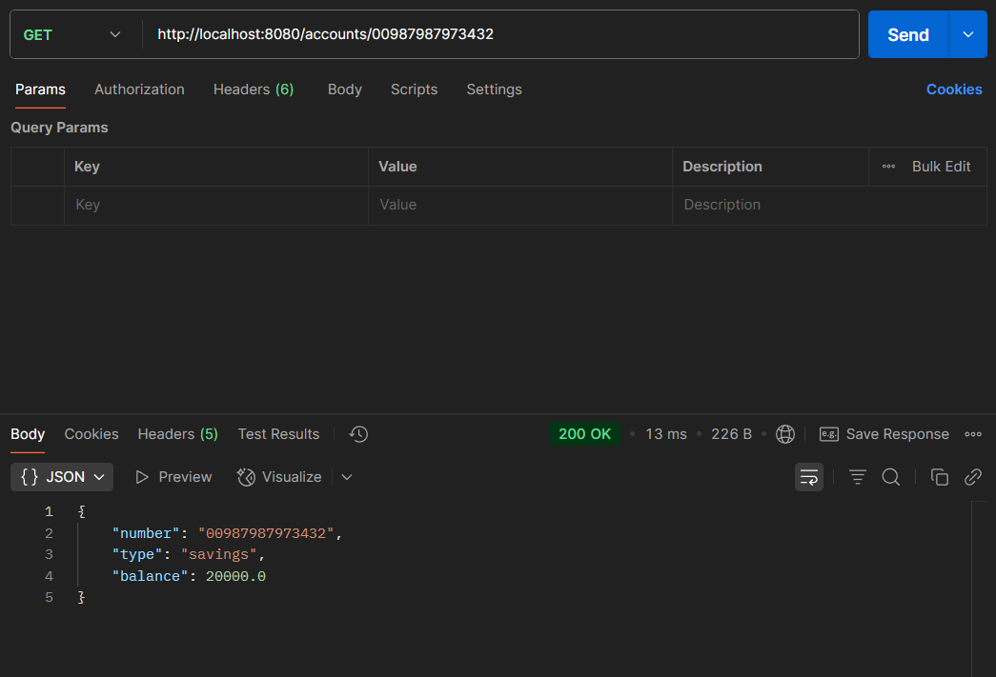

**2. Loan Microservice**

**LoanController.java**

package com.cognizant.loan.controller;

import org.springframework.web.bind.annotation.*;

@RestController

public class LoanController {

@GetMapping("/loans/{number}")

public Loan getLoan(@PathVariable String number) {

return new Loan(number, "car", 500000, 4375, 18);

}

}

class Loan {

private String number;

private String type;

private double loan;

private int emi;

private int tenure;

public Loan(String number, String type, double loan, int emi, int tenure) {

this.number = number;

this.type = type;

this.loan = loan;

this.emi = emi;

this.tenure = tenure;

}

public String getNumber() {

return number;

}

public String getType() {

return type;

}

public double getLoan() {

return loan;

}

public int getEmi() {

return emi;

}

public int getTenure() {

return tenure;

}

}

**Application Properties**

spring.application.name=account

server.port = 8081

**Output:**

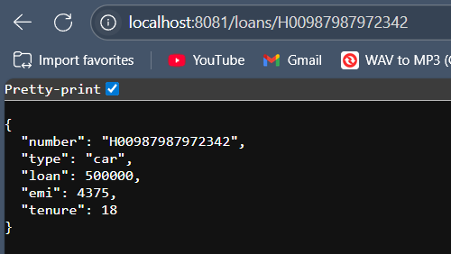

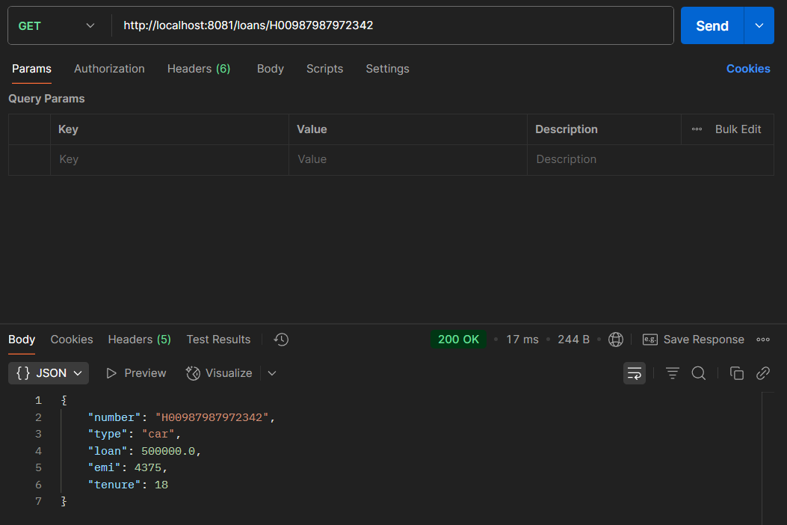

Hence, both Microservices(**account** and **loan**) running at the same time in two different ports(**8080** and **8081**).